**Jose Flores**

**Assignment # 2: Data Models**

**3/28/2025**

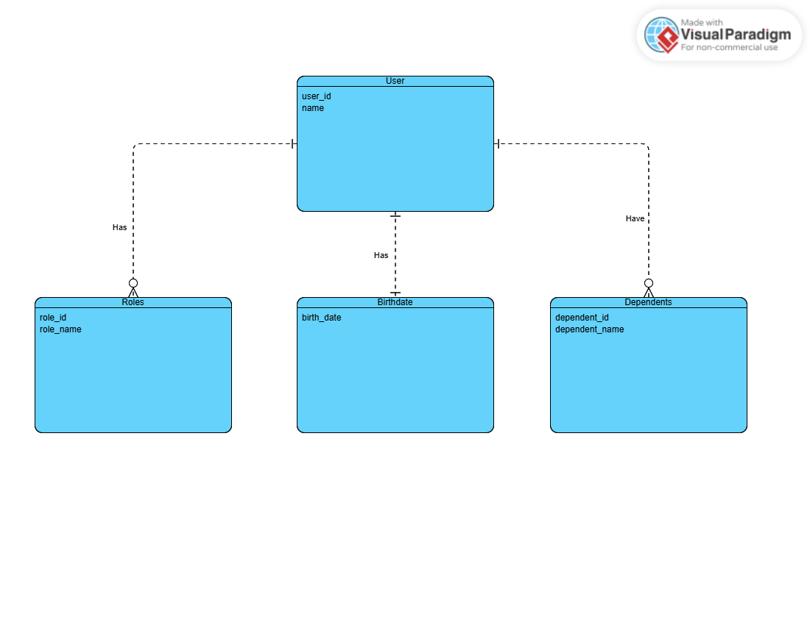

**NoSQL Data Structure:**

{

"user_id": "12345",

"name": "Jose Flores",

"birthdate": "1988-03-20",

"roles": [

{

"role_id": "1",

"role_name": "Video Editor"

},

{

"role_id": "2",

"role_name": "Software Developer"

}

],

"dependents": [

{

"dependent_id": "1",

"dependent_name": "Alex Flores"

},

{

"dependent_id": "2",

"dependent_name": "David Flores"

}

]

}